1. **Question 1:** **Establish S2S Connection hyper-v (child VM) Vm to azure**

ANS: Steps to Establish a Site-to-Site VPN Connection

**Step 1: 1. Configure Azure VNet and VPN Gateway**

* Create a Virtual Network (VNet):
* Sign in to the Azure portal.
* Navigate to Create a resource > Networking > Virtual network.
* Configure the VNet settings (Name, Address space, Subnet, etc.).
* Click Create.

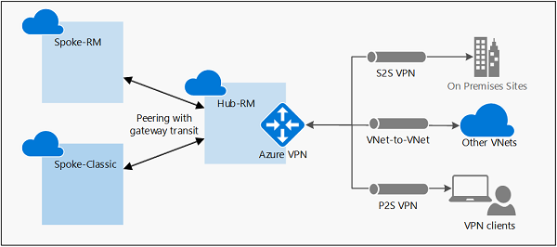

**Step 2: Create a VPN Gateway:**

* Navigate to Create a resource > Networking > Virtual network gateway.
* Configure the VPN Gateway settings (Name, Region, Gateway type: VPN, VPN type: Route-based, SKU: VpnGw1, Virtual network: Select the VNet created earlier).
* Create a new Public IP address or use an existing one.
* Click Review + create and then Create.
* Create a Local Network Gateway:
* Navigate to Create a resource > Networking > Local network gateway.
* Configure the Local Network Gateway settings (Name, IP address of your on-premises VPN device, Address space that will be connected to Azure).
* Click Create.

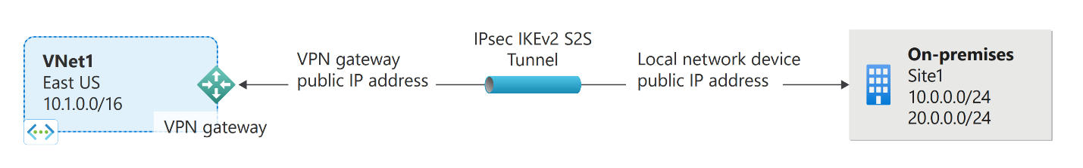

**Step 3: Create a Connection:**

* Go to your VPN Gateway.
* Under Settings, select Connections > Add.
* Configure the connection settings (Name, Connection type: Site-to-site (IPSec), Virtual network gateway: Select your VPN Gateway, Local network gateway: Select your Local Network Gateway).
* Enter a shared key (pre-shared key).
* Click OK to create the connection.



**Step 4: Create Site-to-Site VPN Connection**

* Install RRAS:
* Log in to the Hyper-V VM.
* Open Server Manager.
* Navigate to Add Roles and Features.
* Select Remote Access and proceed with the installation.
* Under Role Services, select Routing and proceed with the installation.
* Configure RRAS:
* Open Server Manager > Tools > Routing and Remote Access.
* Right-click the server name and select Configure and Enable Routing and Remote Access.
* Choose Custom configuration > VPN access and NAT.
* Click Finish, then Start service.
* Configure the VPN Connection:
* In the Routing and Remote Access console, right-click on the server name and select Properties.
* Go to the Security tab.
* Under Authentication Methods, select EAP and configure it to use a certificate (or choose RADIUS Authentication if applicable).
* Under IPv4, click on Static address pool and define the IP address range for VPN clients.
* Click OK to apply the changes.
* Set Up the Site-to-Site VPN:
* Right-click on Network Interfaces and select New Demand-Dial Interface.
* Follow the wizard to create the new interface:
* Name the interface.
* Choose Connect using VPN.
* Select IPSec Tunnel.
* Enter the Azure VPN Gateway public IP address.
* Configure the pre-shared key (same as the one used in Azure).
* Complete the wizard and enable the interface.

**Step 5. Verify the Connection**

* Check the Connection on Azure:
* Go to your Azure VPN Gateway.
* Under Settings, select Connections.
* Verify that the connection status is Connected.
* Check the Connection on Hyper-V VM:
* Open Routing and Remote Access on the Hyper-V VM.
* Expand Network Interfaces and check the status of the VPN connection.

